# CS 255 System Design Document Template

This template lays out all the different sections that you need to complete for Project Two. Each section has guidance to prompt your thinking. You will need to continually reference the interview transcript as you work to make sure that you are addressing your client’s needs. There is no required length for the final document. Instead the goal is to complete each section based on what your client’s needs are. Remove this note when you are finished, and replace all bracketed text with the relevant information.

## UML Diagrams

### UML Use Case Diagram

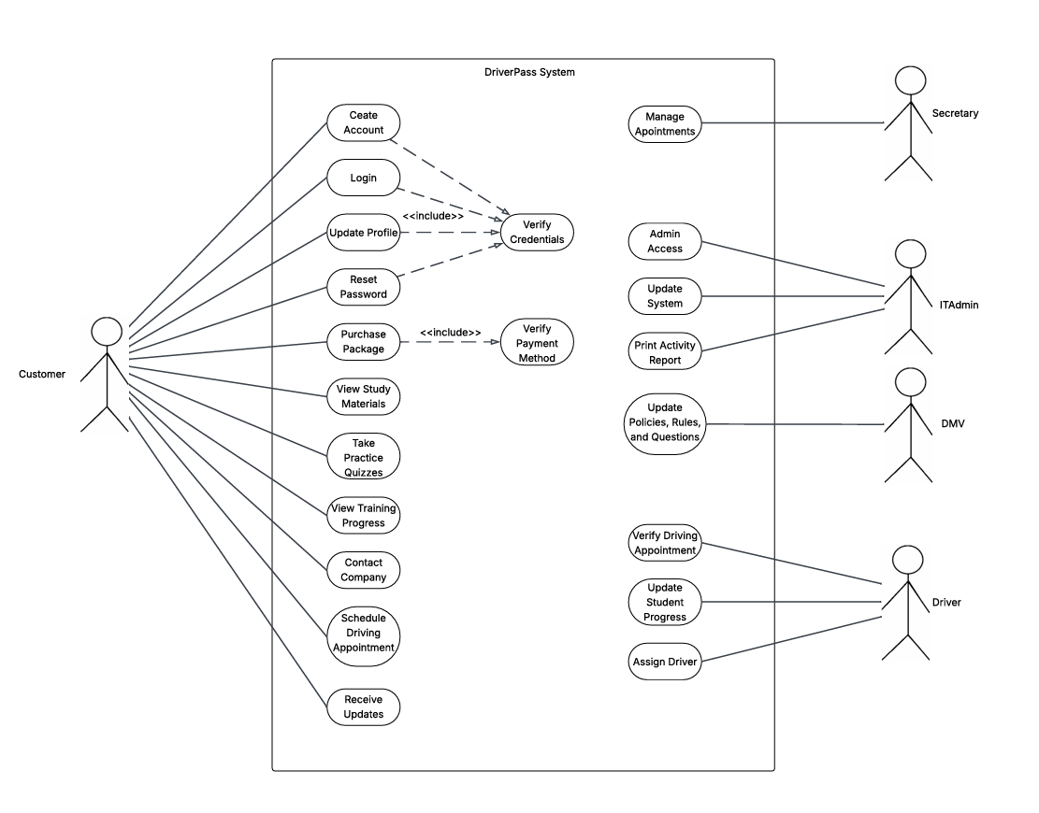

### UML Activity Diagrams

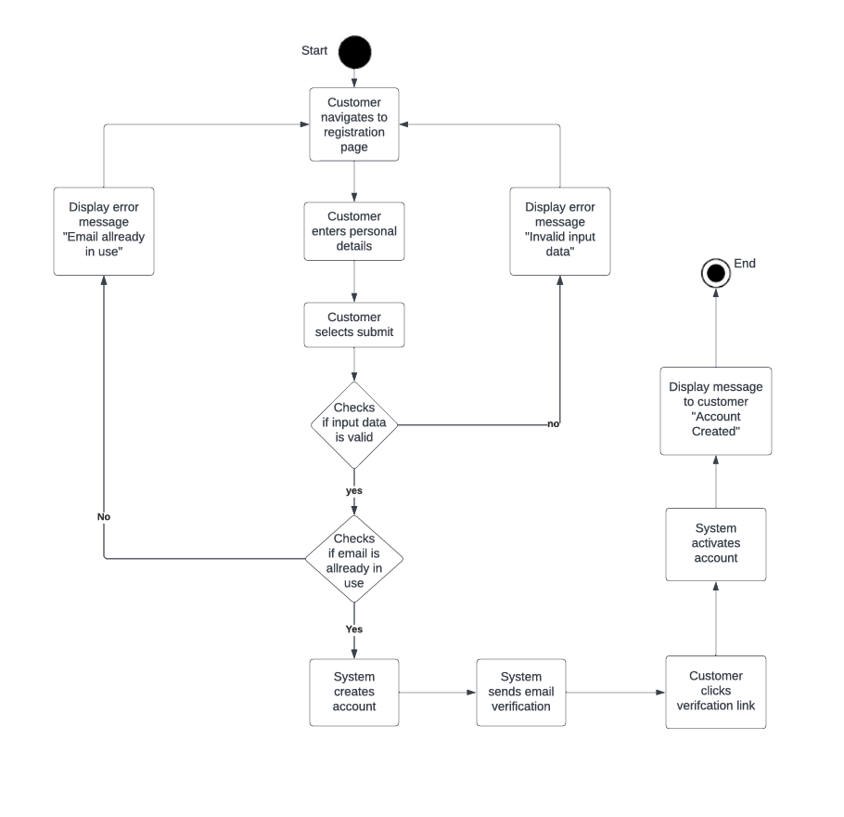

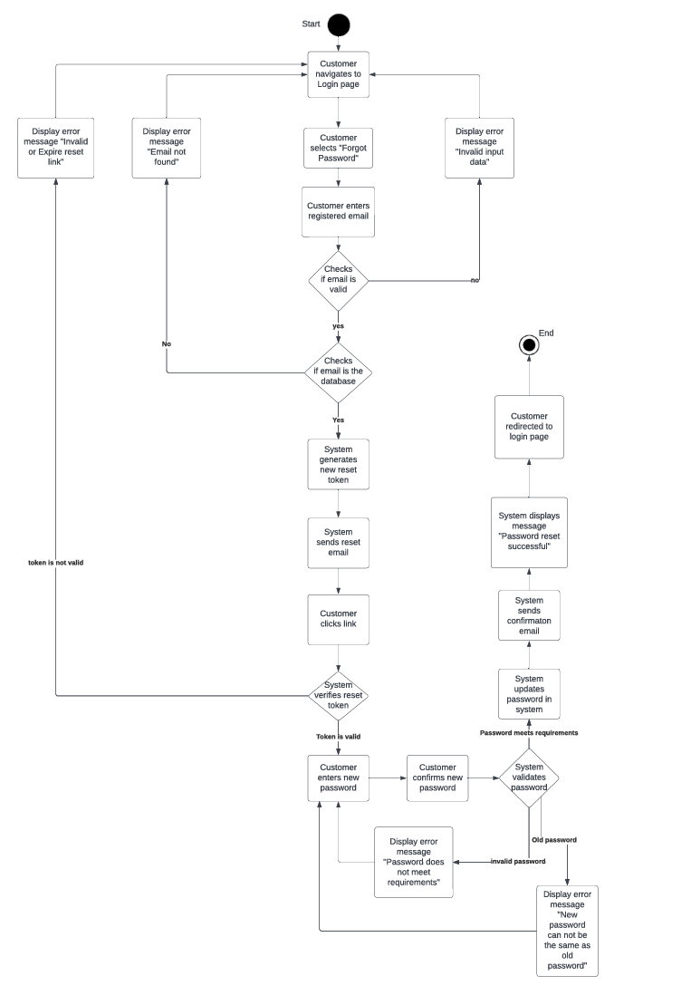

### UML Sequence Diagram

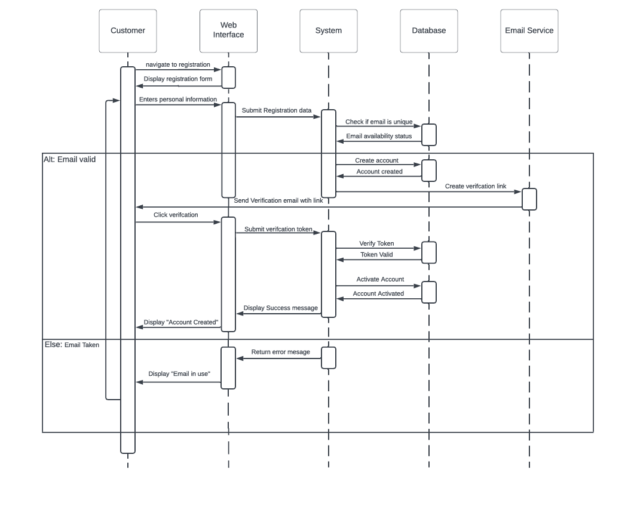

### UML Class Diagram

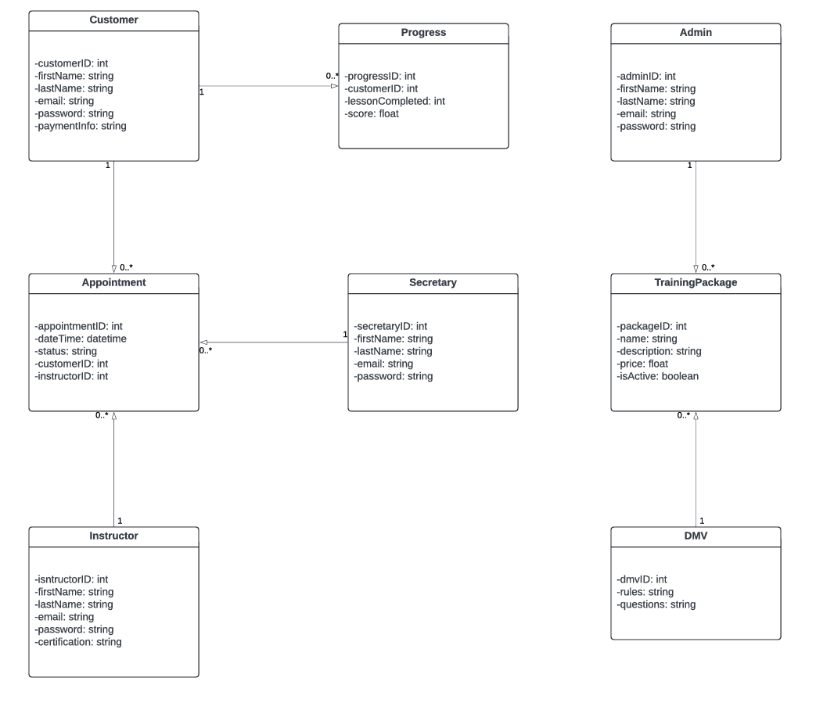

## Technical Requirements

For this system to work there will need to be a reliable cloud service that can handle the expected customer base with the ability to expand in the future. Assuming customers have their own devices and internet to access classes on their own time the employees will need to have their own hardware with a reliable internet service to give everyone access to their accounts. Some kind of web framework is required to manage all the interfaces, logic, and API for things like account creation and passwords. A reliable database is required to store data like tokens and account details. Some kind of software or API integration for sending emails to and from customers. There needs to be some encryption library implementation to store reset tokens and passwords. Some kind of middleware will be needed to authenticate these tokens and other credentials for logins and account creation.